Data Analysis with Python

# Importing Datasets: Dataframe, Feature, Target

## Python packages

* Scientific Computing Libraries

1. Pandas: Data Structures
2. Numpy: Array & Matrices
3. SciPy: Integrals, solving differential equations, optimization

* Visualization Libraries

1. Matplotlib
2. Seaborn

* Algorithmic Libraries

1. Scikit-learn: Machine Learning (Regression, classification, etc.)
2. Statsmodels: Explore data, estimate statistical models and perform statistical tests

## Getting Started with Python Pandas

* df.dtypes()
* df.describe()
* df.info()

## Accessing databases with Python

### SQL API

### DB-API

### Connection Methods (using DB-API)

## Summary

# Data Wrangling

## Dealing with Missing Values

* Drop the missing Values (Variable or Data Entry): df.dropna()
* Replace the Missing Values: df.replace()

## Data Formatting: Correcting Data types

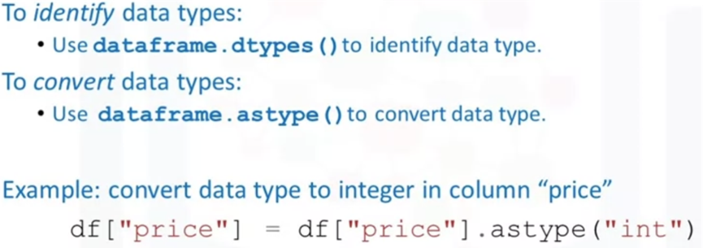

## Data Normalization

* Simple Feature Scaling
* Min-Max
* Z-Score

## Binning

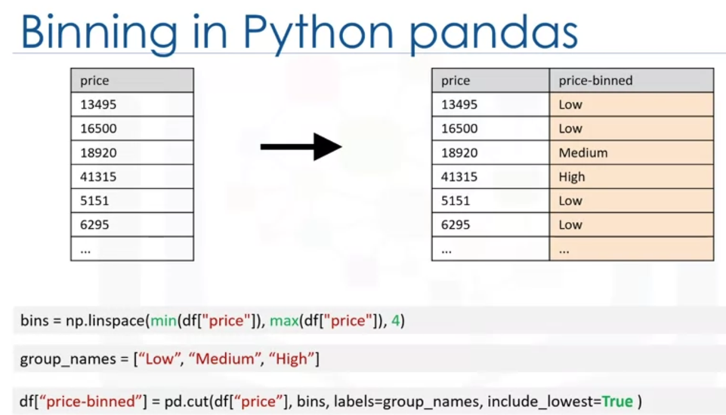

## Turning Categorical Variables into Quantitative Variables

* pd.get_dummies(df[“column”])

## Summary

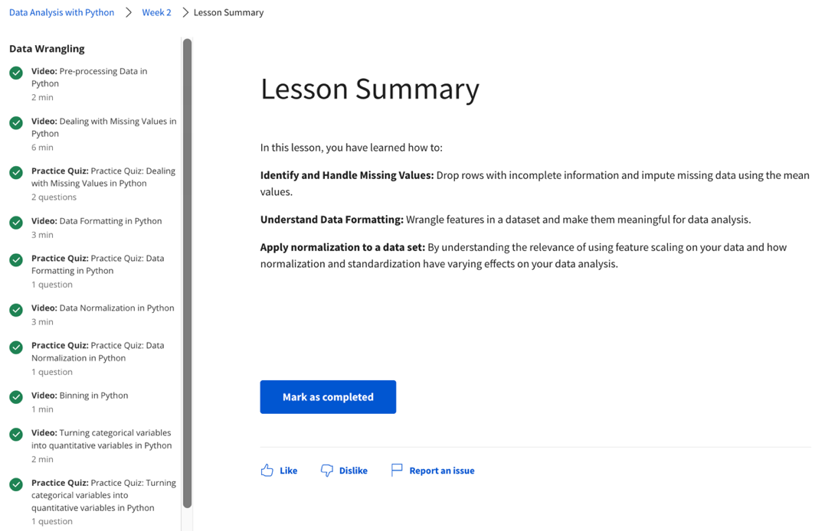

# Exploratory Data Analysis

## Descriptive Statistics

* Short Summaries: df.describe(), Box Plot, Scatter Plot

## Grouping Data

* groupby(), pivot(), heatmaps

## Correlation

* How are the variables dependent to each other?
* Pearson correlation (using SciPy package)

1. Correlation coefficient (0 to 1)
2. P-value (0.01, 0.05 etc)

## Chi-square: Association between 2 categorical variables

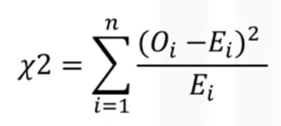

## Summary

# Model Development

## Simple and Multiple Linear Regression’

### Fitting a Linear Model

### Fitting a Multiple Linear Model

### Estimated Linear Model

## Model Evaluation using Visualization

* Regression Plot
* Residual Plot

* Distribution Plots

## Polynomial Regression and Pipelines

### Pipelines

## R-squared and MSE for In-Sample Evaluation

* Mean Squared Error (MSE)
* R-Squared

## Predictions and Decision Making

## Summary

# Model Evaluation

## Model Evaluation and Refinement

### Splitting Data into train and test

### Evaluation Metrics

* K-cross validation
* Cross val score

## Overfitting, Underfitting and Model Selection

Underfitting (left) and Overfitting (right)

### Checking for the most optimal n value

## Ridge Regression

Ridge regression is a regression that is employed in a Multiple regression model when Multicollinearity occurs. Multicollinearity is when there is a strong relationship among the independent variables. Ridge regression is very common with polynomial regression. The next video shows how Ridge regression is used to regularize and reduce the standard errors to avoid over-fitting a regression model

## Grid Search

### Code

## Summary

Check ipynb notebook for 5_Model Evaluation